Experiment 1:

AIM: Design a LED flasher.

Apparatus:

Circuit diagram:

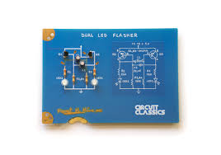

Theory:-

Concept used:-

The concept used for this practical are:-

1. The LED’s will glow with the help of an Arduino board and bread board.
2. Using breadboard test the electronic circuits and certain parts of breadboard are joined together so that electricity will pass from it and by which we can make the electric circuits.
3. Arduino board is connected to computer via USB. The user will write the code in IDE and by using the port COM21 uploads it and executes it in Arduino app.
4. Arduino provides the digital signals with the help of which LED’s will glow accordingly.

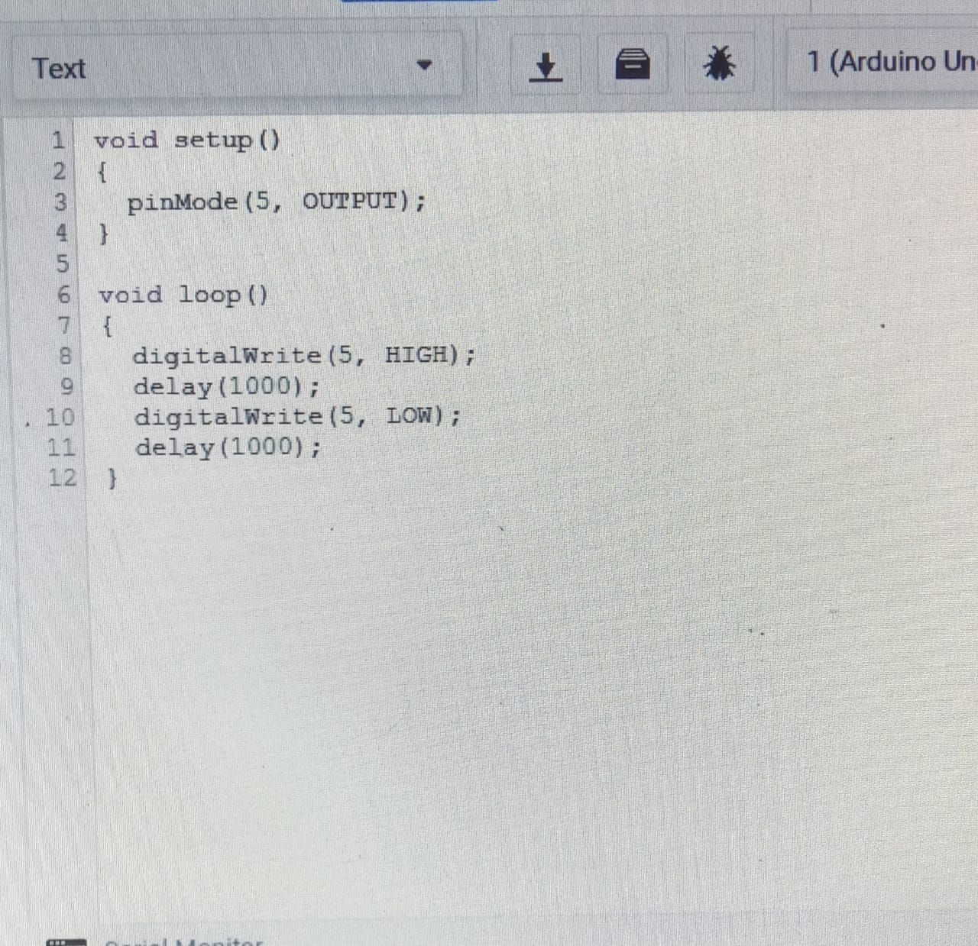

Learning and Observations:-

Learning:-

1. From this task I have learned how to make the series and connection using an Arduino board and breadboard to make the LED’s glow.

2. By this practical I have learned how the wires are connected in breadboard with respect to each other and how the breadboard is helpful in making the electric circuits.

3. I have learned more about the Arduino board that how Arduino works and how current flows through it.

4. The pins should be properly adjustable that is positive point should be connected with positive pin and negative point should be connected with negative pin.

5. I have learned the connections should not be loose and the pins should be inserted properly.

Observations:-

When we pass electrical signals to the Arduino board the LED’s will glow and they will switched off accordingly.

Learning Outcomes:-

1.By doing this experiment I have learned how to make the electric circuits using various hardwares like by the help of an Arduino board and breadboard which is a new device for us to learn and to know more about it.

2. By the help of this experiment I have learned how we can glow the LED’s in various patterns by the help of an Arduino board by making codes according to our need.

3. After doing this experiment I have gained the practical skills in electronics that how to make the circuits using different hardwares and also enchancing my knowledge in coding and have a good work experience.

Problems and troubleshooting:-

1.The Arduino was not properly working so I detached its wire from the computer and connect it again properly and also selected the required Arduino board and Arduino port(COM21) in tools menu.

2.The LED’s were not working properly so I replaced these with the new ones.

3.The circuit was not getting closed because the wires in breadboard were not placed at their appropriate positions so I changed the positions of the wires according to the series pattern.

Precautions:-

1. While doing this experiment we have to keep in mind that circuit should be closed.

2. The connections should not be loose and pins should be inserted properly.

3. The two pins of the LED should be connected at their appropriate point that is the positive point should be connected with p pin and the negative point should be connected with negative pin.